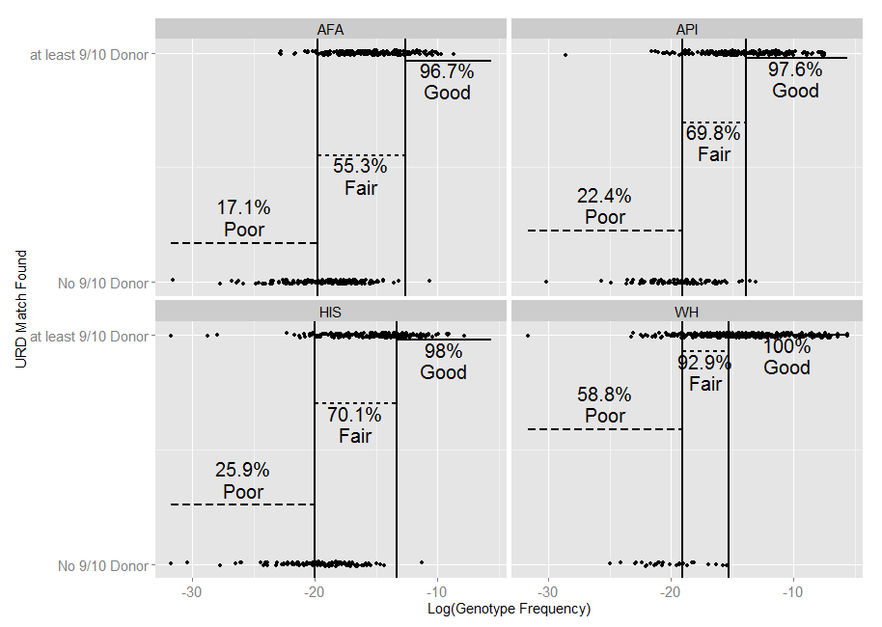

**Figure X: Percentage of pseudo-patients that could identify at least a 9/10 donor by predicted model class and race.** Model classification boundaries are shown along with individual results (slightly jittered to avoid over-plotting) to illustrate the genotype frequency effect within model classes with regard to finding at least a 9/10 URD.